FIR Filters using DSP Processor
12.1 Design and Implementation of FIR High Pass filter using Rectangular Window

Program (MATLAB Code)

clc;
clear;
close all;

% Sampling frequency
Fs = 1000;

% Time vector
t = 0:1/Fs:1;

% Input sinusoidal signal
f = 200;
x = sin(2*pi*f*t);

% FIR High Pass Filter
Fc = 100;
N = 20;

% Rectangular window
b = fir1(N, Fc/(Fs/2), 'high', rectwin(N+1));

% FIR filtering
y = filter(b, 1, x);

% Compensate for FIR group delay
delay = N/2;
y = y(delay+1:end);
t1 = t(1:length(y));

% Plot ONLY clean output
figure;
plot(t1, y, 'r', 'LineWidth', 2);
grid on;

xlabel('Time (s)');
ylabel('Amplitude');
title('FIR High Pass Filter Output using Rectangular Window');

% Display clean sinusoidal portion
xlim([0.1 0.2]);
ylim([-1.1 1.1]);

Output
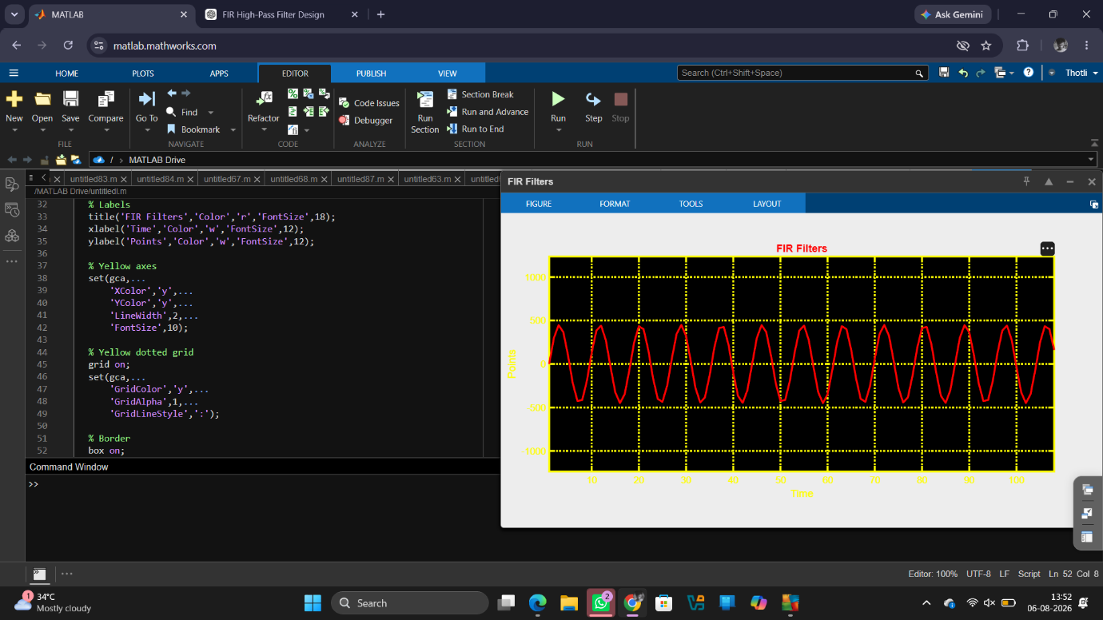
Results
The FIR filter was successfully designed using the Rectangular Window method.
2. The designed filter was implemented and executed on the TMS320C5416 DSP Starter
Kit.
3. The input signal was processed through the FIR filter, and the filtered output was
obtained.
4. The output response verified the desired filtering operation, demonstrating the successful
implementation of the FIR filter on the DSP processor.

